**Exercise 3: Assertions in Junit**

**Scenario:** You need to use different assertions in JUnit to validate your test results

**Code:**

*AssertionsTest.java -*

package com.example.junit;

import org.junit.Test;

import static org.junit.Assert.*;

public class AssertionsTest {

*@Test*

public void testAssertions() {

// Assert equals

*assertEquals*(5, 2 + 3);

// Assert true

*assertTrue*(5 > 3);

// Assert false

*assertFalse*(4 < 3);

// Assert null

*assertNull*(null);

// Assert not null

*assertNotNull*(new Object());

}

}

**OUTPUT: (SCREENSHOTS)**

* **ALL TEST CASES PASSED**

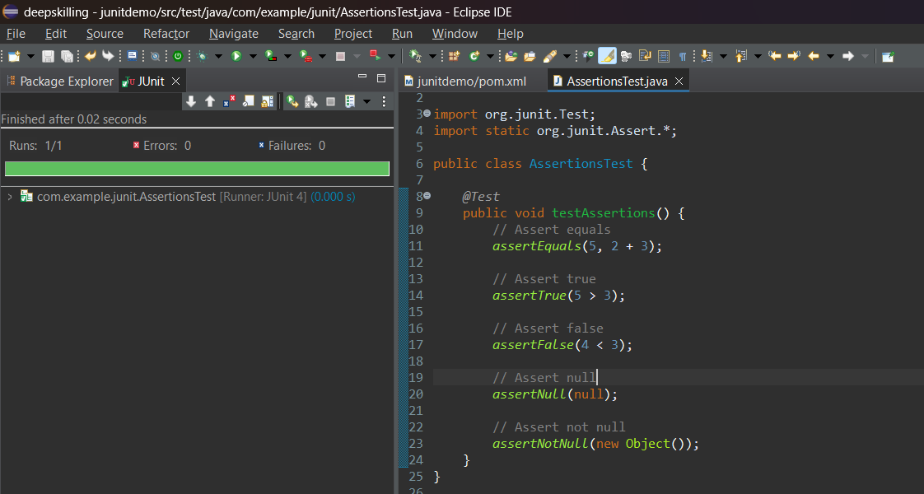

* **IF ANY ONE TEST CASE FAILS WE GET THIS OUTPUT**

